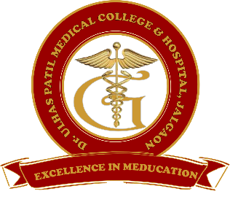 | Godavari Foundation’s  DR. ULHAS PATIL MEDICAL COLLEGE & HOSPITAL,  Recognized by Medical Council of India, Approved by Central Govt. of India, New Delhi,  Letter no. MCI-34(41)/2012-med./158127, dated 05/02/2013  Affiliated to Maharashtra University of Health Sciences, Nashik [College Code-1306]  Jalgaon-Bhusawal Road, NH-6, Jalgaon Kh, Tal. & Dist. Jalgaon 425309  Tel. No. (0257)2366657, 2366678 Fax No. 0257-2366648  Email ID : dupmcj@yahoo.in Web Site : www.dupmc.ac.in

Date: 02/05/2022
Students are exposed to the organization and operational features of the Immunization Clinic functioning in the hospital as per WHO guidelines for childhood immunization

Dr. Ulhas Patil Medical College runs a immunization clinic for children under Pediatrics department.
Parents of beneficiaries are given complete information about immunization schedule and its importance. Cold chain equipment is available. Temperature recording is done two times daily.
Immunization clinics are also run in collaboration of Primary Health Centre in Rural Health training centre under Community medicine Department.
National immunization schedule, Universal immunization programme, cold chain, vaccine vial monitor, adverse effects following immunization, Organization and management of immunization services are included in Syllabus of Community medicine course. Immunology is covered in Microbiology and Pharmacology subjects during second year. The topic is also covered in Pediatrics theory and clinical postings.
Visits are arranged to immunization clinic, Primary health centre, rural health training centre for undergraduate students, where they are shown storage of various vaccines and diluents, auto disable syringes, cold chain equipment, immunization records and also vaccination of children during sessions.
Interns during their compulsory rotatory internship are posted to rural health training centre and pediatrics department. They observe immunization process and work in immunization clinic. They are given hands on training of storage of vaccine, handling of vaccines, recording of temperature of ice lined refrigerators in temperature register, record keeping and actually inoculating children during sessions.
Students are also instructed regarding injection safety procedures during immunization sessions.
Topic of immunization is given good weightage in Community medicine theory and practical examinations.
Apart from this, Pulse Polio immunization is carried out on National Immunisation days where interns are posted along with healthcare workers from Primary Health Centres.
Our hospital is one of the sites for COVID-19 vaccination sites in Jalgaon district.
That’s how, in our institute students are adequately exposed to childhood immunization process so that after passing the MBBS program, they are competent to administer vaccines, manage universal immunization programme as medical officers.

Prepared by Coordinator Dean

